Spaghetti and Measles diagram
Improvement Cymru Academy

What is a Spaghetti Diagram?
The Spaghetti Diagram is a tool to help you establish the optimum layout for a department or ward based on observations of the distances travelled by patients, staff or products, e.g. x-rays.
Spaghetti diagrams expose inefficient layouts and identify large distances travelled between key steps. The spaghetti diagram is a simple mapping tool, helping to identify areas where time can be saved by visualising unnecessary movement of products, staff or patients. It gives you a visual overview of the geography of the process.

When to use it?
The spaghetti diagram is useful when you want to assess time wasted through unnecessary movement through a ward, clinic, department or whole hospital. By reviewing and drawing the ‘current’ spaghetti map, you can see where there is potential to make processes more efficient and improve layouts to reduce distances travelled.

How to use?
- Decide what you are going to observe – e.g. product, staff or patient flow. You may decide to analyse a number of these simultaneously by using different coloured lines to represent each flow.
- Involve representatives from your team in the process of drawing the spaghetti diagram. Explain what is being done and what the potential benefits may be for both the team (minimising waste of effort) and patients (improved experience).
- Ask estates for a diagram (or draw your own) of the floor plan of the area you are working with. Draw lines on it to show the flow of movement as it is now, e.g. a patient attending a diabetic review, or a nurse on a ward changing a patient’s catheter.
- By analysing the lines, you can identify any areas with unnecessary movement.
- Next, assess your diagram to help you redesign the process. Remember lines present on a spaghetti diagram represent movement and therefore waste. Can you bring two points closer together to optimise the flow? This can act as a starting point for redrawing a new spaghetti diagram to reflect the desired flow.
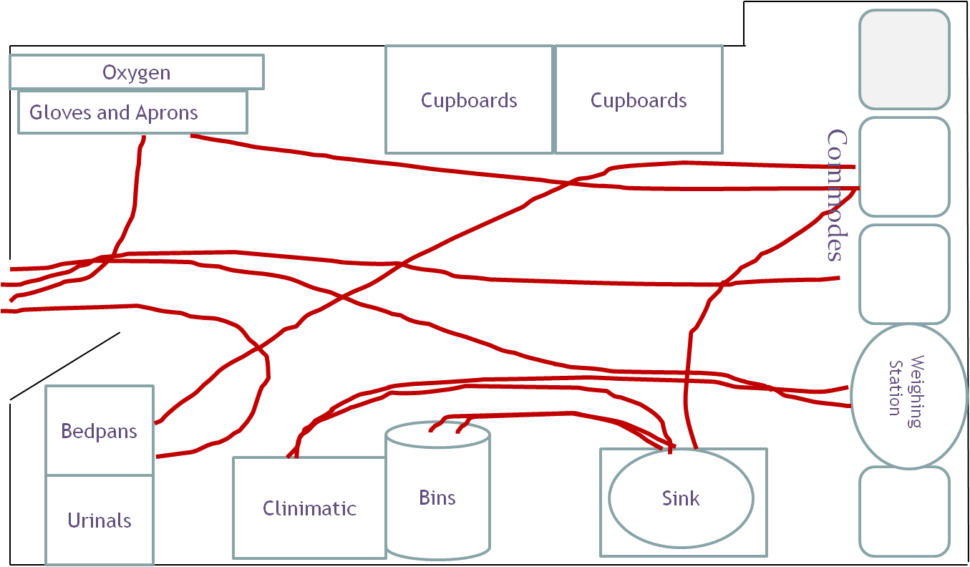
Spaghetti diagrams are used to identify how a process is conducted physically in an environment. Where a problem or incident (e.g. falls) occurs on an ongoing basis, a measles plot can be used to identify where it happens most.

What is a Measles Diagram?
A defect location check sheet (also known as a defect map or a measles chart) is a structured way of collecting and analysing data that provides a visual image of the item being evaluated, so that data can be collected visually rather than merely collecting a count of the number of defects.

When to use it?
A measles chart can be useful to track where incidents are happening e.g. slippages in a kitchen. A common practice in quality assurance or even in Six Sigma is to count the number of defects (incidents) found. If you keep track of the defect rate, you could use an attribute chart (attribute charts are a set of control charts specifically designed for counts data). Attribute charts monitor the process location and variation over time in a single chart to monitor, control and continuously improve upon defect rates, but what is missing is where the defects are located. Again, much of Six Sigma in Lean has to do with visualising the variation, waste, or defects.

How to use?
- Decide what you are going to observe – e.g. product, staff or number of slippages or where patients’ falls occur on wards and have used different colours for different times of day etc.
- Involve representatives from your team in the process of plotting the dots on the measles diagram. Explain what is being done and what the potential benefits may be for both the team (minimising waste of effort) and improved experience.
- Ask estates for a diagram (or draw your own) of the floor plan of the area you are working with.
- Plot dots where each “defect” is happening.

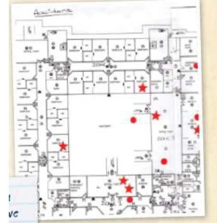

What next?
Use a tool such as fish bone analysis to identify why incidents happen most frequently in the area(s) you have identified.

References
Ihi.org. (2019). IHI Home Page. [online] Available at: http://www.ihi.org/ [Accessed 2 Feb. 2019].
Improvement.nhs.uk. (2019). spaghetti-diagram | NHS Improvement. [online] Available at: https://improvement.nhs.uk/resources/root-cause-analysis-using-five-whys/ [Accessed 2 Feb 2019].
Sixsigmadaily.com. (2019). [online] Available at: https://www.sixsigmadaily.com/measles-charts/ [Accessed 25 Sep. 2019].Bicheno, J (2014). The Lean Tool Box. Buckingham: PICSIE Books

