5 why’s- Root cause analysis
Improvement Cymru Academy

What is 5 Why’s?
The 5 why’s tool is a simple improvement tool which can help define the relationship between a problem and its root cause. Through repeatedly asking the question ‘why?’ (Ideally, five times), it is possible to cut through the layers of a problem to get to identify a cause (the 5 Why’s method is part of the Toyota Production System. Developed by Sakichi Toyoda, a Japanese inventor and industrialist, the technique became an integral part of the Lean philosophy) (Planview, 2019).

Background
The 5 why’s originated within Toyota as they developed their manufacturing methodologies. It forms a critical component of their problem solving training and is part of the induction into the Toyota production system. Very often, the answer to the first ‘why?' will prompt another ‘why?' The answer to the second ‘why?' will then prompt another and so on; hence the name, the 5 why’s strategy (Ohno, 2014).
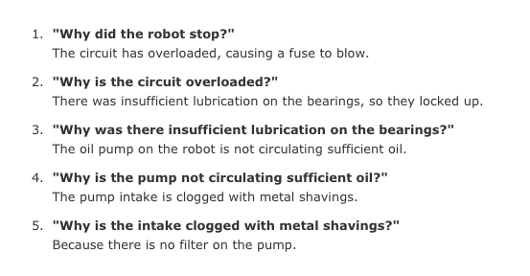
(Open, 2019)
When to use it?
The 5 why’s tool quickly helps identify the source of an issue or problem. You can focus resources in the correct areas and ensure you are tackling the true cause of the problem, not just its symptom.
In order to answer each “why” question, significant information or analysis maybe required. The key is to avoid assumptions and encourage the team to keep drilling down to the real root cause. If you try to fix the problem too quickly, you may be dealing with the symptoms not the problem, so use 5 why’s to ensure that you are addressing the cause of the problem. Remember, if you don’t ask the right questions, you won’t get the right answers.
How to use?
- Write down the specific problem. This helps you formalise the problem and describe it accurately. It also helps a team focus on the same problem.

- Use brainstorming to ask why the problem occurs then write the answers down.

- If these answers do not identify the source of the problem, ask ‘why?’ again and write the answers down.

- Repeat the process until the team agrees that they have identified the problem’s root cause.

- This may take fewer or more than 5 ‘why’s?’

Example
1. The patient's diagnosis of skin cancer was considerably delayed. Why?
2. The excision biopsy report was not seen by the surgeon. Why?
3. The report was filed in the patient's notes without being seen by the surgeon. Why?
4. A new system was placed to put the report in section 4 of the notes. Why?
5. The surgeons had not had communication on this change. Why?

The root cause - that the doctor’s other tasks were seen as more important than seeing a biopsy report. The system has now been changed. A copy of all biopsy reports is now sent directly to the consultant surgeon responsible for the patient and no reports are filed unless they have been signed by a doctor.

What next?
Once you have identified the root cause of the issue identified, the next suggested step is to complete a cause and effect diagram (Fishbone Diagram). The fishbone diagram helps you explore all potential or real causes that result in a failure or problem.
You will need to communicate the outcomes to others to ensure that the root cause of the problem is understood and that everyone is focused on working on the problem area, not treating its symptoms (Improvement NHS, 2019).

A word of caution
Asking why 5 times alone can force users down a single causal pathway. Problems within complex systems, rarely have only one cause. Other Improvement tools such as a Fishbone diagram can be more effective at identifying multiple causes of a problem. The 5 why’s tool was invented to be used by a team, not by sole individuals?

References
Ihi.org. (2019). IHI Home Page. [Online] Available at: http://www.ihi.org/ [Accessed 2 Feb. 2019].
Improvement.nhs.uk. (2019). Root cause analysis - using five whys | NHS Improvement. [Online] Available at: https://improvement.nhs.uk/resources/root-cause-analysis-using-five-whys/ [Accessed 2 Feb 2019].
Ohno, T. (2014). Toyota production system. London: CRC Press.
Open. (2019). what is a 5 Whys? Step-by-Step Guide to Running a 5 Whys Exercise. [Online] Available at: https://open.buffer.com/5-whys-process/ [Accessed 2 Feb. 2019].
Planview. (2019). The 5 Whys of Lean | Planview LeanKit. [online] Available at: https://www.planview.com/resources/articles/5-whys-of-lean/ [Accessed 2 Feb 2019].

